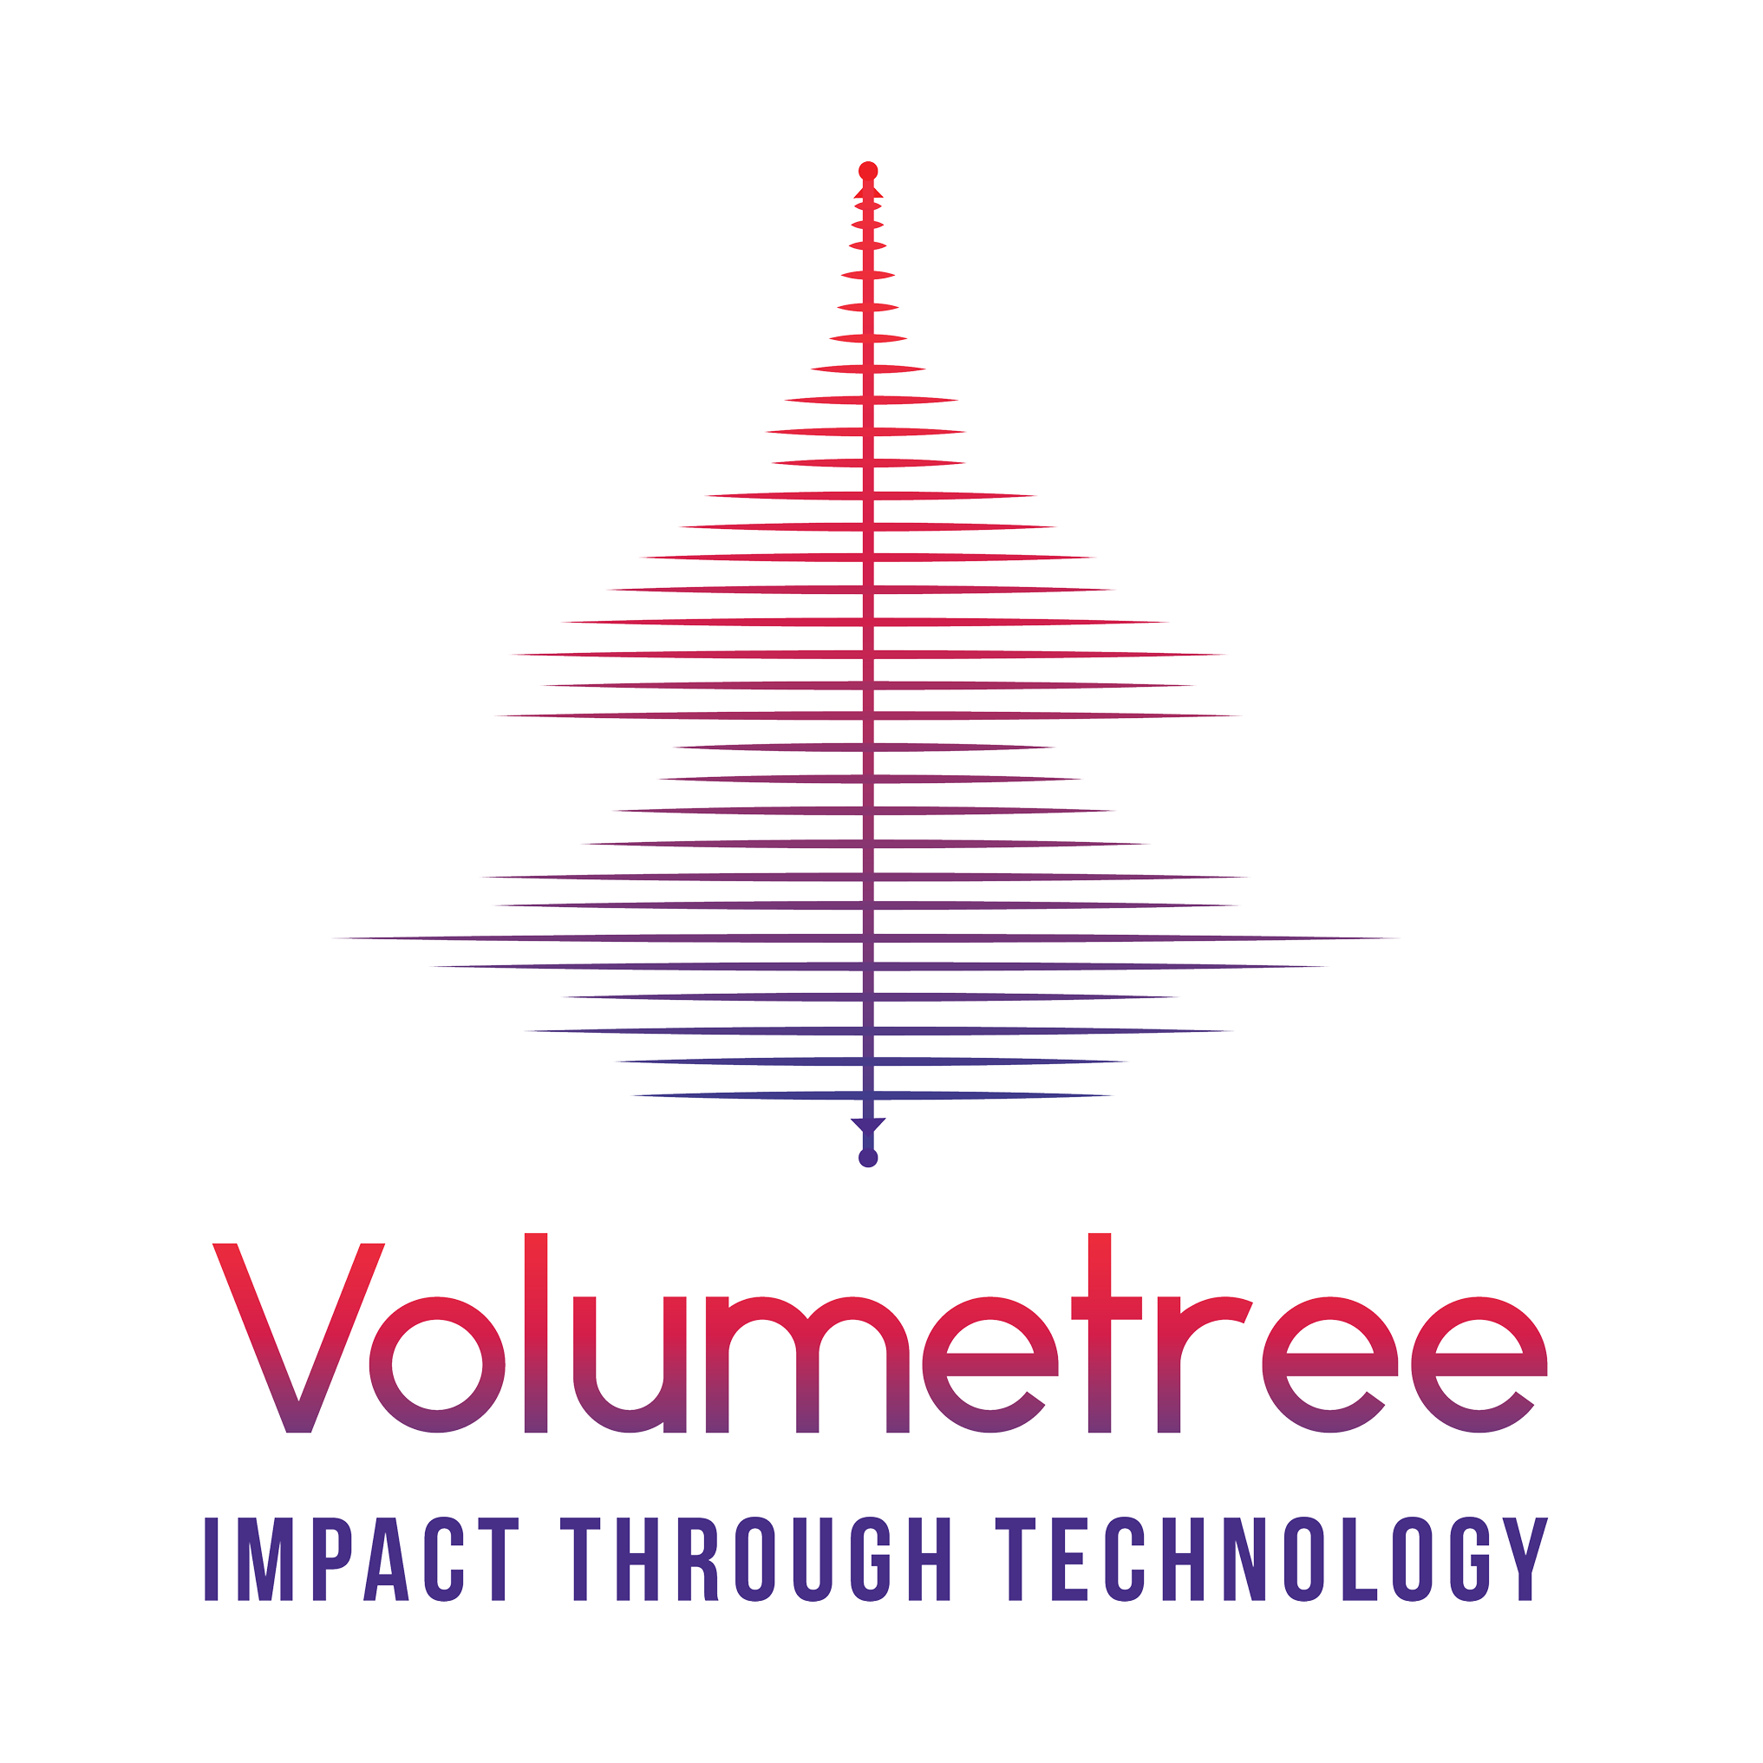

Product Requirements Document [Free Template]

by Volumetree

This work is licensed under a Creative Commons Attribution 4.0 International License

Table of Contents

1. Company Introduction

2. Definition and Objectives

2.1 Definition Table

2.2 Objectives

3. Feature list and Priority

4. User Flow Wireframes

5. Insights & Analytics

6. Future Work

This document can be easily filled by a founder, project manager, or any person who is in charge of building your product.

This product requirements document or PRD template will help you define the value and the purpose of the product (or app) that you want to build.

Here’s what you can use this document for:
- What must be built
- How it functions and behaves
- Who is it for
- How it benefits the end-user Free PRD Template by Volumetree

1. Company Introduction

Use this section to introduce yourself, your company (if you have formed one) and your team. This will help your development partners or your team get a better idea of who they will be dealing with.

<write your company’s introduction here>

2. Definition and Objectives
Describe your idea properly in this section. Ideally, describe your idea in a single sentence that illustrates what your idea is. An example of an objective is:

“I want to create a gift recommendation engine to help men foster better relationships with their partners through periodic and thoughtful romantic gestures.”

2.1 Definition Table
Use this table to define the what, why, who, and how of your product idea.

What is the problem?
Who is experiencing it?
How will you solve it?
Why is your solution better?

2.2 Objectives

Vision
Goals
Ideal Customer Persona

3. Feature list and Priority
Use the table below to write down essential features that you believe your app must have. Additional features such as creating groups/pages or platform monetization can come later.

Feature priority levels: “nice to have”, “should have”, “must have”, “cannot have”

Fill this table with information related to each specific feature in your app or product.
Feature name | Add the name of your feature
Priority of the feature | Add the priority level of this feature
Description of the feature | Describe what this feature is and does
Goal the user wants to reach | Example: user wants to post a photo
Problem it solves for the user | Example: easy photo sharing with friends
Not doing | Add what this feature is not supposed to be

4. User Flow Wireframes
If you have created sketches (or wireframes) of what you product can look like, add them below in an image format. This section will help you visually explain the user flow and visual layout of your product.

5. Insights & Analytics
You can use this section to define:
- Key Performance Indicators: actions you want your user to take
- Starting points: where your user starts while using your product
- Target: what you want the user to achieve
- Time to completion: how much time the user takes to reach the target

Your Insight: We think <insert feature name> can help <insert user type> do <insert name of action> successfully.

Key Performance Indicator | Starting Point | Target | Time to completion
Example: User opens your app to post a photo | User goes to app home screen | User goes to compose a post screen | Less than 1 minute
<insert your own KPI here> | <insert your user’s starting point> | <insert your target for a user> | <insert ideal time taken by user to achieve target>

6. Future Work
Add the future plans for your product here. Your development partner might find items that are easier to implement and help you create a better version of your app in the beginning.

Feature priority levels: “nice to have”, “should have”, “must have”, “cannot have”

Feature name | Priority | Time to completion
<insert additional feature here>

Want to turn your app idea into a product?
Our specialized teams will design, develop, and launch your idea as a lean product
(just like Uber) with must-have features for your first customers.

Start today to save up to 70% in development costs!

Book FREE Consultation

